EMBEDDED WEB SERVER USING ESP32
CodTech IT Solutions Pvt. Ltd.
Domain: Embedded Systems
Project Report
Submitted By:
Name: T. Amulya
Intern ID: CITS3856
Duration: 4 Weeks

Abstract:
The Embedded Web Server using ESP32 is an Internet of Things (IoT) based project designed to provide wireless control of electronic devices through a web browser. In this system, the ESP32 microcontroller acts as a web server and hosts a webpage over a Wi-Fi network. Users connected to the same network can access the webpage and remotely control an LED by sending ON and OFF commands. The project demonstrates the practical implementation of networking concepts in embedded systems and provides a simple approach to device automation.
The ESP32 microcontroller is widely used in IoT applications because of its built-in Wi-Fi and Bluetooth capabilities, high processing speed, low power consumption, and cost-effectiveness. In this project, these features are utilized to establish communication between the hardware and the user interface. The web page hosted by the ESP32 acts as a control panel through which users can interact with the system. The project highlights how embedded devices can communicate over networks and perform control operations efficiently.
This project serves as an introductory example for understanding embedded web servers and their applications in smart homes, industrial automation, and remote monitoring systems. The concepts implemented in this project can be extended to control multiple devices and sensors, making it an important building block for advanced IoT systems.

Introduction:
Embedded systems are specialized computing systems designed to perform dedicated tasks with high reliability and efficiency. They are widely used in consumer electronics, automotive systems, industrial automation, healthcare devices, and communication systems. With the rapid growth of Internet of Things (IoT) technology, embedded systems are increasingly being integrated with communication networks to provide remote access and control functionalities. This integration has enabled the development of smart systems capable of performing tasks automatically and efficiently.
An embedded web server is a software application that runs on a microcontroller and provides access to devices through standard web protocols. Instead of requiring dedicated software, users can interact with the system through a web browser, making it highly flexible and user-friendly. Embedded web servers are commonly used in smart home systems, industrial monitoring applications, weather stations, and remote data acquisition systems.
The ESP32 microcontroller has emerged as one of the most popular platforms for developing IoT applications because of its powerful features and wireless communication capabilities. It integrates Wi-Fi and Bluetooth modules within a single chip, reducing hardware complexity and overall cost. The ESP32 can function as both a client and a server, making it ideal for implementing web-based control systems.
In this project, the ESP32 acts as a web server and hosts a webpage containing control buttons for an LED. Users can access this webpage using a smartphone, laptop, or computer connected to the same Wi-Fi network. By clicking the buttons on the webpage, commands are transmitted to the ESP32, which then controls the LED accordingly. This project provides practical knowledge about embedded systems, networking concepts, and IoT applications.

Objectives:
• To understand the working of ESP32 as an embedded web server.
• To establish Wi‑Fi communication.
• To develop a browser-based LED control system.
• To gain practical exposure to IoT concepts and web technologies.

Components Used:
1. ESP32 DevKit V1
2. LED
3. Jumper Wires
4. Wi‑Fi Network
5. Arduino IDE
6. Wokwi Simulator

Methodology:
The methodology adopted for the Embedded Web Server using ESP32 project consists of hardware implementation and software development. Initially, the requirements of the project were identified, and suitable components such as the ESP32 development board, LED, resistor, and jumper wires were selected. Since the ESP32 has built-in Wi-Fi capability, no external communication module was required, which simplified the circuit design and reduced overall complexity.
The next step involved designing the circuit and establishing connections between the ESP32 and the LED. The LED was connected to GPIO pin 2 of the ESP32 through a current-limiting resistor. Proper grounding and power connections were ensured to guarantee reliable operation of the system. After completing the hardware setup, the software part of the project was developed using the Arduino IDE. The necessary libraries for Wi-Fi communication and web server functionality were included in the program.
The ESP32 was programmed to connect to a specified Wi-Fi network using the network SSID and password. Once connected, it was configured to operate as a web server on port 80. A simple webpage containing ON and OFF buttons was created and hosted by the ESP32. The webpage served as a graphical interface through which users could interact with the system and send commands to control the LED.
To verify the performance of the designed system, the circuit and program were tested using the Wokwi simulation platform. Various operating conditions were examined to ensure proper communication between the webpage and the ESP32. The simulation results confirmed that the system was functioning correctly and that the LED responded accurately to user commands. Thus, the methodology adopted in this project provided a simple, reliable, and effective approach for implementing an embedded web server using ESP32.

Circuit Description:
The circuit of the Embedded Web Server project is simple and consists mainly of an ESP32 development board and an LED. The ESP32 serves as the central processing unit and performs the functions of both the microcontroller and the web server. It contains built-in Wi-Fi functionality, which enables communication with devices connected to the same wireless network. This eliminates the need for additional communication modules and makes the system compact and economical.
An LED is used as the output device to demonstrate the remote control capability of the system. The positive terminal (anode) of the LED is connected to GPIO pin 2 of the ESP32, while the negative terminal (cathode) is connected to the ground terminal through a resistor. The resistor limits the amount of current flowing through the LED and protects it from excessive current that could damage the component. The entire circuit can be assembled using jumper wires and a breadboard, making it suitable for both practical implementation and simulation.
The ESP32 board is powered through a USB connection, which supplies the necessary voltage for operation. When the GPIO pin is set to a HIGH state, current flows through the LED and causes it to glow. When the GPIO pin is set to a LOW state, the current flow is interrupted, and the LED turns OFF. This simple arrangement forms the basis of the remote control mechanism implemented in the project.
The overall circuit is highly reliable, easy to construct, and requires only a few components. Due to its simplicity and flexibility, the same circuit can be expanded in future applications to control multiple devices such as relays, motors, fans, and home appliances

Working Principle:
The Embedded Web Server project operates based on the principles of wireless communication and web server technology. Initially, the ESP32 microcontroller connects to a Wi-Fi network using the SSID and password specified in the program. After establishing a successful connection, the ESP32 obtains an IP address from the network and starts a web server on port 80. This IP address acts as the access point through which users can communicate with the system.
A webpage containing control buttons is hosted by the ESP32. Any device connected to the same Wi-Fi network, such as a smartphone, laptop, or personal computer, can access the webpage through a web browser. The webpage provides a user-friendly interface that enables users to send commands to the microcontroller.
When the ON button is pressed, an HTTP request is sent from the browser to the ESP32 web server. The microcontroller processes the request and sets GPIO pin 2 to a HIGH state. As a result, the LED connected to that pin receives current and glows. Similarly, when the OFF button is pressed, another HTTP request is transmitted to the ESP32. The microcontroller then changes the state of GPIO pin 2 to LOW, interrupting the current flow and turning the LED OFF.
This process takes place continuously and in real time, enabling users to remotely control the connected device. The implementation demonstrates how embedded systems and web technologies can work together to provide efficient, reliable, and user-friendly automation solutions. The same principle can be extended to various IoT applications involving sensors, actuators, and smart devices.

Results and Output:
The Embedded Web Server using ESP32 was successfully implemented and tested using the Wokwi simulation platform. The ESP32 established a stable connection with the Wi-Fi network and operated as a web server without any communication issues. The webpage hosted by the ESP32 was successfully accessed through a browser, demonstrating the ability of the system to provide remote control functionality.
The LED connected to GPIO pin 2 responded correctly to the commands received from the webpage. When the ON button was selected, the LED turned ON immediately, and when the OFF button was pressed, the LED switched OFF. The response time of the system was observed to be satisfactory, and the operation remained stable throughout the testing process. No significant errors or delays were encountered during the simulation.
The experimental results confirmed the reliability and effectiveness of the ESP32 in implementing web-based control systems. The project demonstrated that wireless communication could be successfully integrated with embedded systems to achieve remote device management. The obtained results validate the suitability of the ESP32 platform for Internet of Things applications and smart automation systems.
Furthermore, the successful execution of the project highlights the potential of embedded web servers in modern technological applications. The developed system can be easily expanded to include multiple devices and sensors, making it suitable for advanced automation and monitoring applications. Overall, the project achieved all its intended objectives and provided a practical demonstration of IoT-based control systems.

Applications and Future Scope:
The Embedded Web Server project has numerous applications in modern automation systems. It can be used in home automation systems to control lights, fans, and electrical appliances remotely. Industrial monitoring and control systems can also utilize embedded web servers for machine management and process control. The project can be extended for smart agriculture applications, where irrigation systems can be controlled remotely.
Additionally, embedded web servers are widely used in smart cities, healthcare monitoring systems, energy management systems, and environmental monitoring applications. The technology enables real-time access and control of devices from anywhere, thereby increasing efficiency and convenience.
The future scope of this project is extensive because it can be expanded into more advanced IoT applications. Multiple devices such as relays, motors, and sensors can be integrated into the system for enhanced functionality. Cloud platforms and mobile applications can be incorporated to enable remote access from anywhere in the world. Security features such as password authentication and encrypted communication can be implemented to improve system reliability.
The project can also be integrated with voice assistants such as Google Assistant and Amazon Alexa for voice-based control. Advanced sensors for temperature, humidity, gas detection, and motion detection can be added to create intelligent automation systems. With the rapid growth of IoT technology, embedded web servers are expected to play a significant role in future smart environments and connected devices.

Conclusion:
The Embedded Web Server using ESP32 project was successfully designed and implemented to demonstrate the concept of remote device control using wireless communication. The ESP32 microcontroller was configured as a web server capable of hosting a webpage through a Wi-Fi network. By accessing this webpage through a browser, users were able to control an LED connected to the ESP32 using simple ON and OFF commands. The successful operation of the system verified the effectiveness of integrating embedded systems with web technologies for IoT applications.
This project provided practical knowledge about microcontrollers, Wi-Fi communication, HTTP protocols, and web server implementation. It also helped in understanding the interaction between hardware and software components in embedded systems. The use of the ESP32 development board proved to be advantageous due to its low power consumption, built-in wireless capabilities, ease of programming, and cost-effectiveness. Furthermore, the simulation carried out using the Wokwi platform demonstrated that the designed system operates reliably and efficiently.
The developed system can serve as a basic framework for more advanced Internet of Things applications. Additional sensors, actuators, and security features can be incorporated to enhance the functionality of the system. The project can be extended to home automation, industrial monitoring, smart agriculture, healthcare systems, and remote data acquisition applications. Overall, the Embedded Web Server using ESP32 project successfully achieved its objectives and demonstrated the importance of embedded web technologies in the development of intelligent and connected systems. The knowledge gained through this project provides a strong foundation for designing and implementing future IoT-based automation solutions.
Source Code:
#include <WiFi.h>
#include <WebServer.h>
const char* ssid = "Wokwi-GUEST";
const char* password = "";
WebServer server(80);
int ledPin = 2;
void handleRoot() {
String html = "<html><body>";
html += "<h1>ESP32 Embedded Web Server</h1>";
html += "<p><a href=\"/on\"><button>LED ON</button></a></p>";
html += "<p><a href=\"/off\"><button>LED OFF</button></a></p>";
html += "</body></html>";

server.send(200, "text/html", html);
}

void handleOn() {
digitalWrite(ledPin, HIGH);
server.sendHeader("Location", "/");
server.send(303);
}

void handleOff() {
digitalWrite(ledPin, LOW);
server.sendHeader("Location", "/");
server.send(303);
}

void setup() {
Serial.begin(115200);

pinMode(ledPin, OUTPUT);

WiFi.begin(ssid, password);

Serial.print("Connecting");

while (WiFi.status() != WL_CONNECTED) {
delay(500);
Serial.print(".");
}

Serial.println();
Serial.println("WiFi Connected");
Serial.print("IP Address: ");
Serial.println(WiFi.localIP());

server.on("/", handleRoot);
server.on("/on", handleOn);
server.on("/off", handleOff);
server.begin();
Serial.println("Web Server Started");
}
void loop() {
server.handleClient();
}

Output Screenshots:
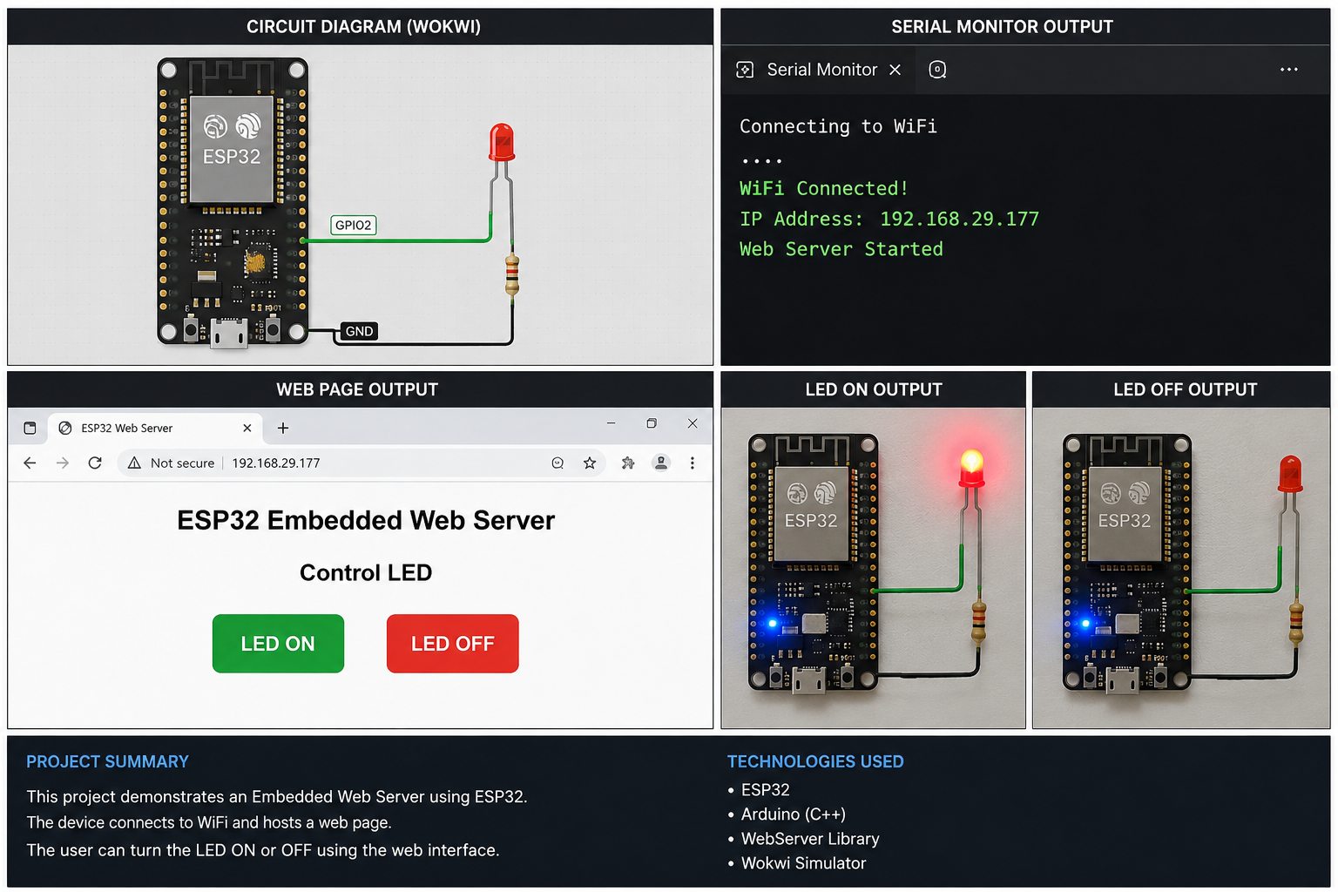

References:
1. ESP32 Documentation by Espressif Systems.
2. Arduino IDE Documentation.
3. Wokwi Simulator Documentation.
4. ESP32 WebServer Library Documentation.

